Unilever

|  |  |
| --- | --- |
| **Summary** | In this Assignment, we have to evaluate Unilever and understand how the programmatic services are integrated into the applications. |
| **URL** | <https://www.unilever.com/> |
| **Category** | Web |
| **Author** | Sriram Ravindran  Rishab Shekar Gunashekar |

What is the Product?

Included Products

How are they Selling it?

Retail Stores

Retails Stores - Mobile Applications

Website for Vendors

How is it Priced?

Market-Oriented Pricing Strategy

Premium Pricing Strategy

Product Bundle Pricing Strategy

What Promotions are they using?

What algorithmic marketing services are they using?

What datasets do you think you will need to build these algorithmic services?

How frequently will data change?

How would you store these datasets?

Review the jobs/career site and search for Data/ Data science positions. After review of the site, what technologies and programmatic services is the company using?

How is the company tracking visitors?

TPC-DS Dataset

Discuss who is this dashboard targeted towards and the use cases you will accomplish with it:

Your company wants to augment this dataset with a new dataset which will be in csv format:

Describe what tools (xsv, Python) will be used for data cleanup

Prototype your application

# What is the Product?



Unilever plc is a British multinational consumer goods company headquartered in London, England. Unilever's products are available in around 190 countries Unilever owns over 400 brands, with a turnover in 2017 of 53.7 billion euros, and thirteen brands with sales of over one billion euros. Unilever is technically considered a recession-resistant company.

## **Included Products**

Unilever products include food, confections, energy drinks, baby food, soft drinks, cheese, ice cream, tea, cleaning agents, coffee, pet food, bottled water, toothpaste, chewing gum, frozen pizza, pregnancy tests, juice, margarine, beauty products, personal care, breakfast cereals, pharmaceutical and consumer healthcare products. Unilever is the largest producer of soap in the world.

# How are they Selling it?

## **Retail Stores**

Unilever sells their brands and products via retail stores such as Stop & Shop, Walmart etc; They don’t hold their own website or shopping application for selling their brands.

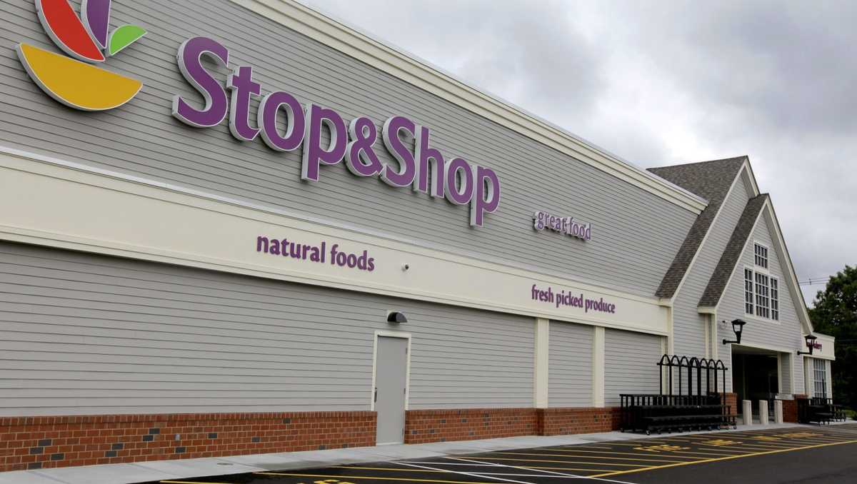

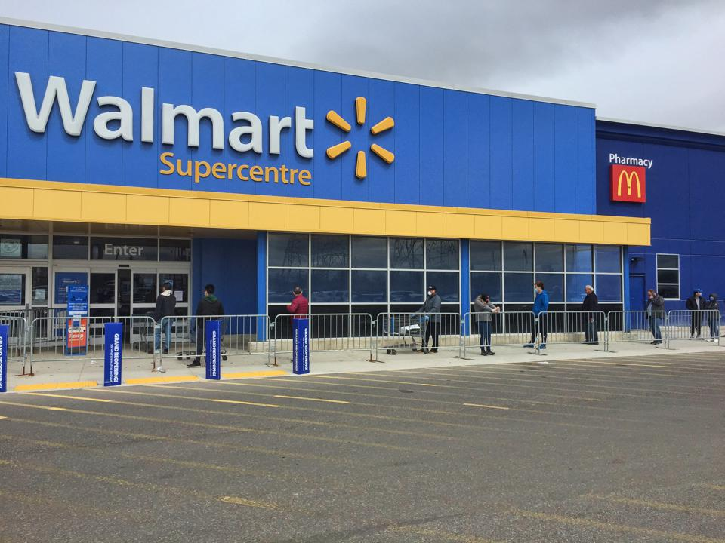

## **Retails Stores - Mobile Applications**

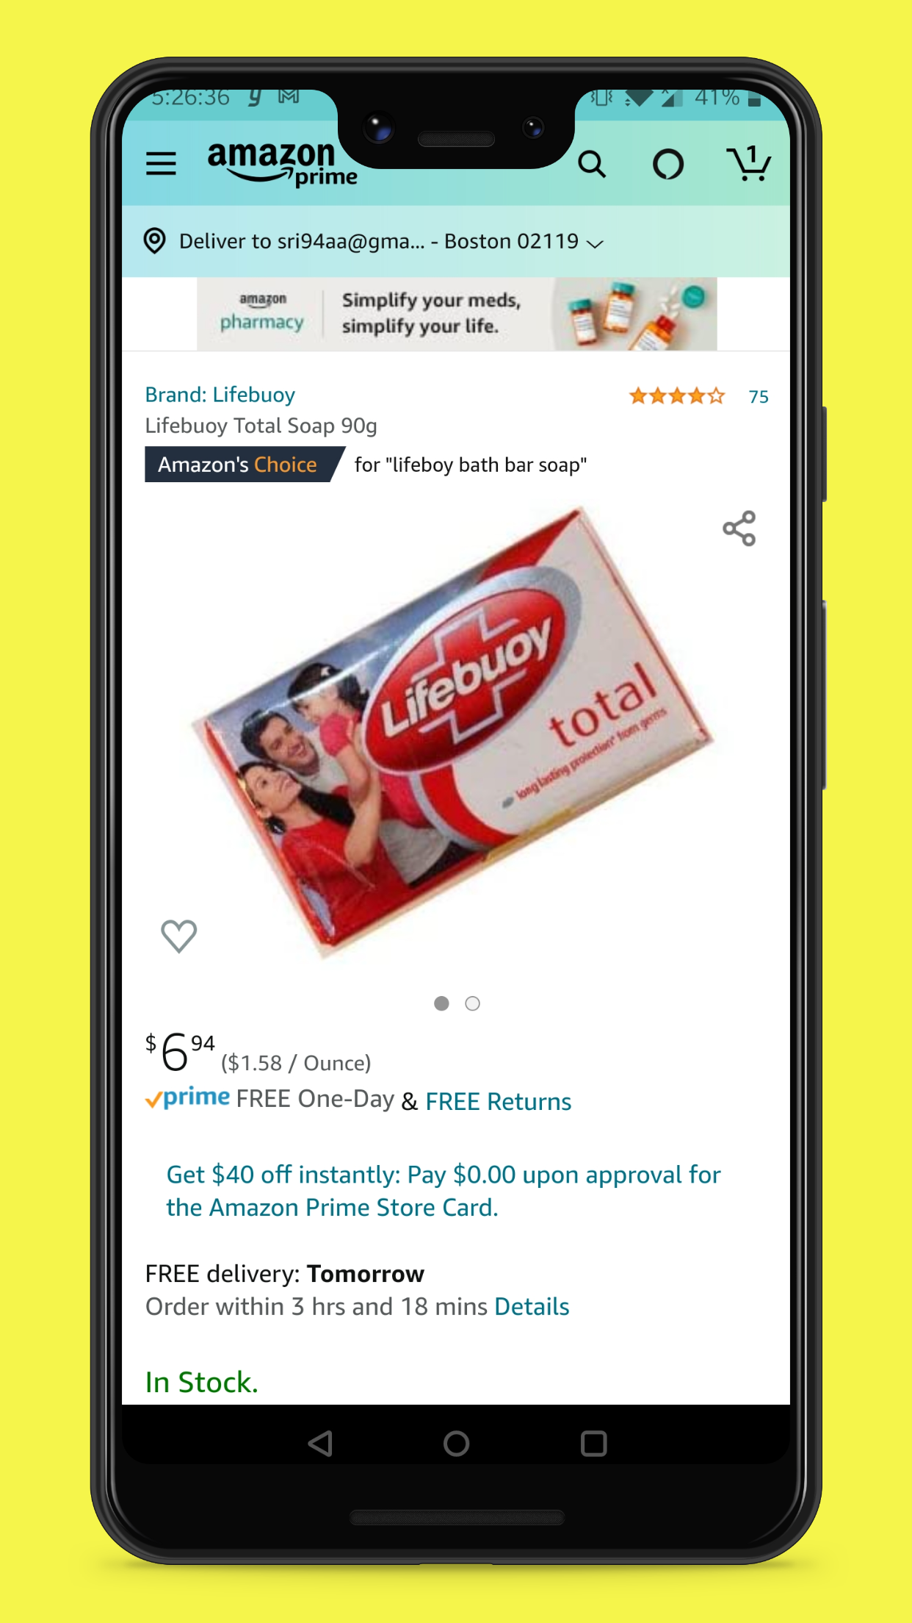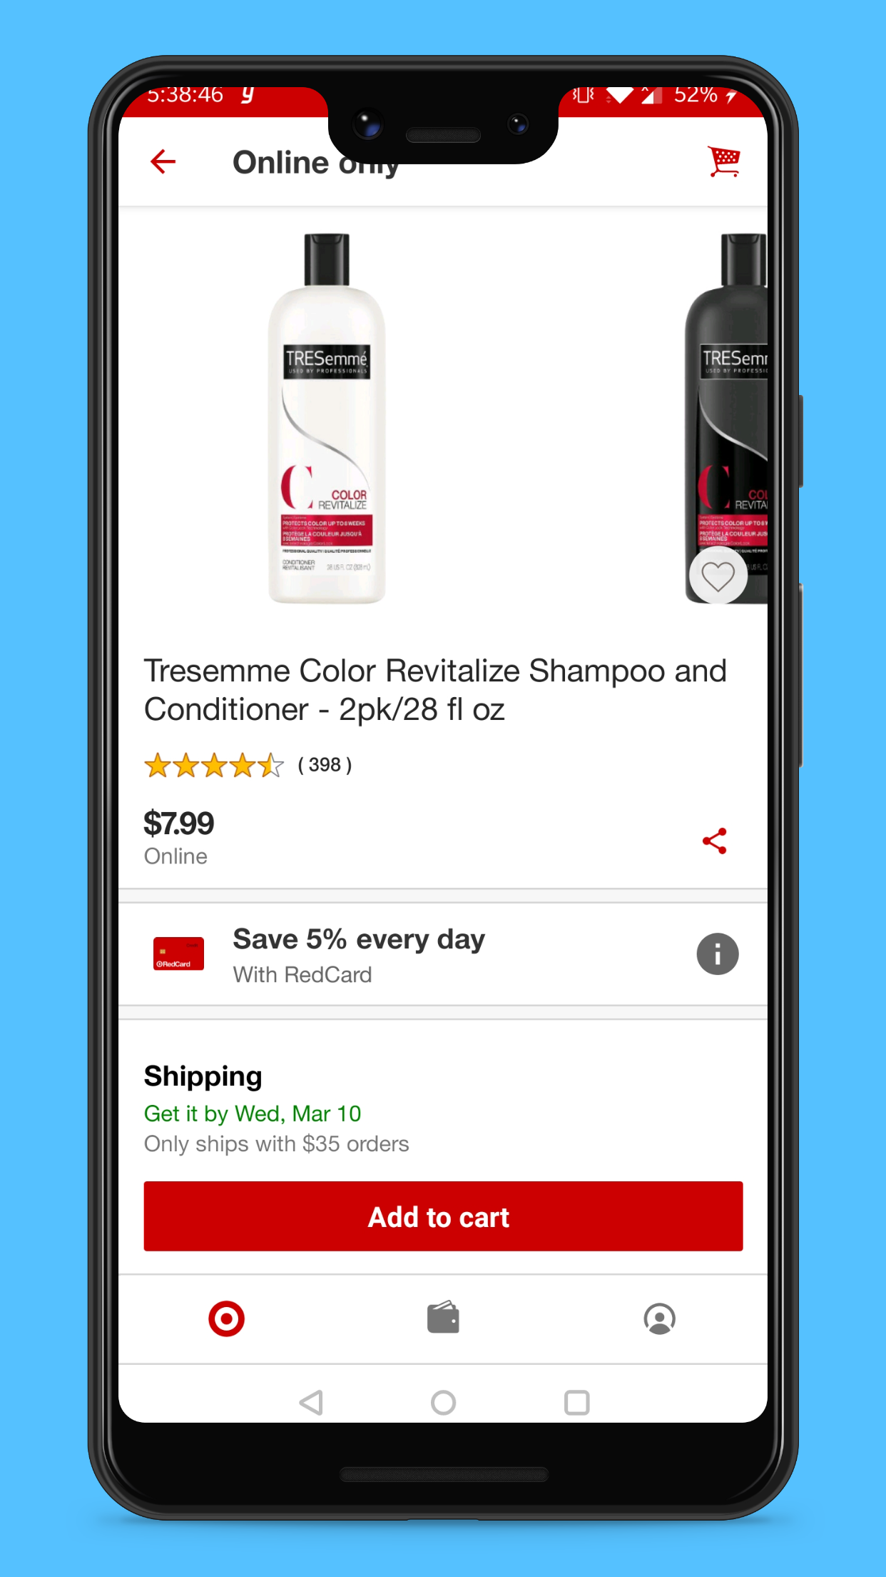

## **Website for Vendors**

Unilever also sells their products via an online website for Vendors.

<https://www.unileverfoodsolutions.us/>

# How is it Priced?

The most significant pricing strategies in Unilever’s consumer goods business are as follows:

## Market-Oriented Pricing Strategy

The market-oriented pricing strategy entails setting price points based on consumer goods market factors. Unilever uses competitors pricing to determine the most appropriate prices.

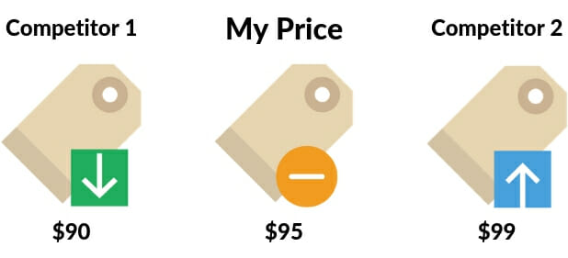

## Premium Pricing Strategy

The premium pricing strategy involves prices that are higher than competitors. For instance, products like Dove, Unilever applies moderately high prices that correspond to the premium quality of the brand.

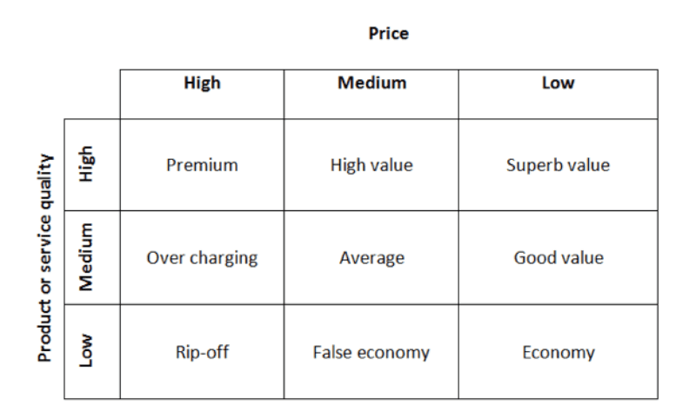

## 

## Product Bundle Pricing Strategy

The company occasionally offers products in bundles set at discounted prices.

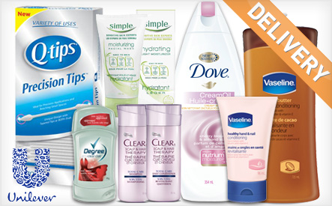

# What Promotions are they using?

## Unilever uses the following promotional tactics, arranged according to significance:

1. Advertising
2. Sales Promotion
3. Public Relations
4. Personal Selling
5. Direct Marketing

Amongst the above methods Advertising is the primary way of promoting their products.

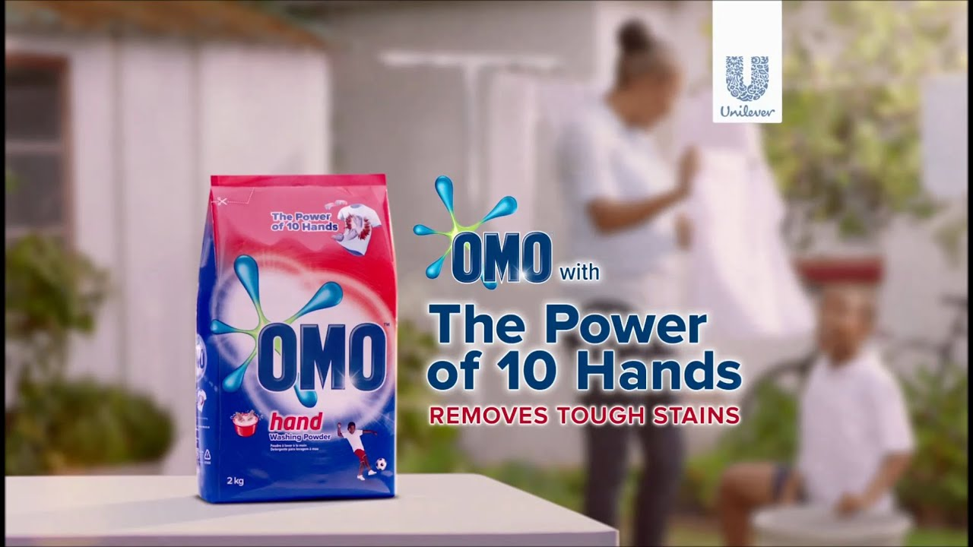

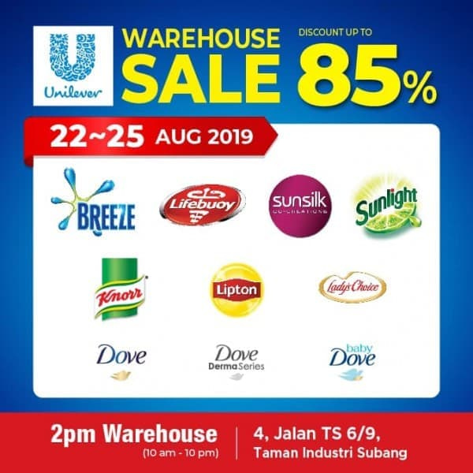

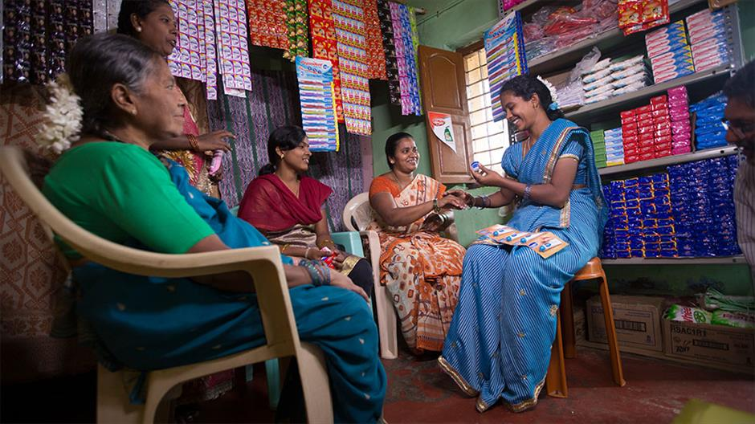

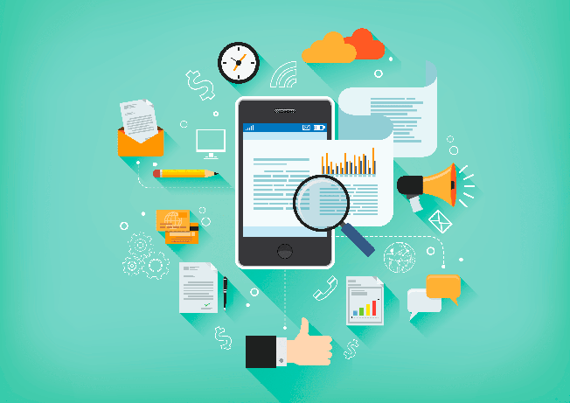

# 

# What algorithmic marketing services are they using?

## Advertising

Advertising is the primary marketing service used by Unilever like Television Ads, Billboards etc



## Assortment

Since Unilever sells the product via retailers like Amazon, Walmart, these retailers use Mass-market assortment strategy to sell all their products. They aim to appeal to the mass-market and offer as many products and varieties as possible, catering to a much bigger customer base.

## Promotions

Unilever provides promotions like Discounts on some of their brands & Large-pack promotions that drove both uplift as well as incrementality. Hypermarkets were the place where the promotions drove more incremental volume.

## Pricing

Since Unilever follows Pricing strategy, they also promote their products targeting different types of customers by changing the prices. Some products are priced high to remain consistent with the premium quality, while some others are set at a low price.

# 

# What datasets do you think you will need to build these algorithmic services?

### Datasets:

* Count of products sold at the end of each day can contribute to the dataset. This can be further scrutinized by obtaining the count of products sold on each day in each region(Location), will help the company to understand the needness of the products based on the region.
* Maintaining the Feedback data would help them analyze the psychology of the user and help the company to increase the Customer Lifetime Value (LTV).

## How frequently will data change?

The data will change frequently based on the customer needs. Constant data updates will aid us in identifying patterns and recommending appropriate product changes.

## How would you store these datasets?

* RDBMS, XSV, CSV & JSON can be used to store the data
* In order to evaluate consumer reviews we can store the data in the form of Binary Images.

# 

# Review the jobs/career site and search for Data/ Data science positions. After review of the site, what technologies and programmatic services is the company using?

## **Role:**

Data Science Manager - Shop Recommendations

## **Technologies and programmatic services**

Technology Stack: Python, R, Spark, Scala, Javascript, Java, Gitlab, Kotlin, Kubernetes, AWS, React, Bue, Angular JS, Docker, Jenkins

Tools: Tableau, Trifacta, Google Analytics, XSV

ML: Recognition of Image by monitoring the customer analysis efficiency and feedbacks, Time Series model is developed to understand the LTV of users

# How is the company tracking visitors?

Since the company is selling all it’s products via retail stores, there is no exact way the company can track visitors. Rather it can be achieved by getting the Cookie datas from their retail partners.

# Start with the​ TPC-DS Dataset from Snowflake. Design a dashboard that will leverage queries from Einstein Analytics to Snowflake to build the dashboard.

Einstein Analytics Link for dashboard:

<https://northeasternuniversity73-dev-ed.my.salesforce.com/analytics/wave/dashboard?assetId=0FK4x000000AghlGAC&orgId=00D4x000006tPdg&loginHost=na150.salesforce.com&urlType=sharing&pageId=55e90bcc-50e6-487b-9d1d-1bf3424a9d4f&savedViewId=8wk4x000000XgoCAAS&analyticsContext=analyticsTab>

# Discuss who is this dashboard targeted towards and the use cases you will accomplish with it:

# Your company wants to augment this dataset with a new dataset which will be in csv format:

## Describe what tools (xsv, Python) will be used for data cleanup

Tools like XSV, Trifacta, Google refine can be used to clean up data.

# Prototype your application

### Dataset Link:

<https://www.kaggle.com/pankajjsh06/ibm-watson-marketing-data-analysis-prediction>

### Google Colab : <https://colab.research.google.com/drive/1KTUtJFw7znq2sDbJSVPbFf7TmBMtVGxS?usp=sharing>

Einstein Analytics Link for dashboard:

<https://d5y000001cnoduai-dev-ed.my.salesforce.com/analytics/wave/dashboard?assetId=0FK5Y0000009QQCWA2&orgId=00D5Y000001cnOd&loginHost=na156.salesforce.com&urlType=sharing&pageId=cc8e3d99-cefd-4fdc-8966-b632bb5e0f62&savedViewId=8wk5Y0000008Ul4QAE&analyticsContext=analyticsTab>

# 